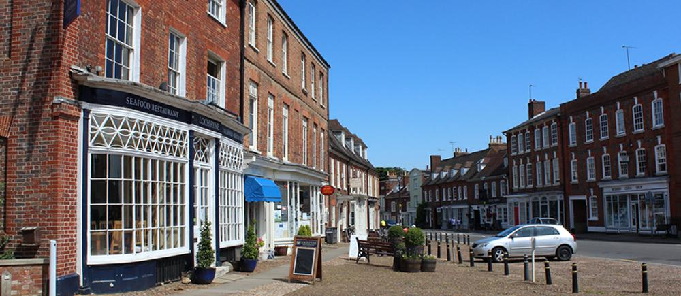

**English:** As writers we will be developing our writing skills through the genres of Portal Stories and Playscripts. A*s usual there will be weekly work on: grammar, punctuation, spelling ,comprehension, and weekly guided reading; as well as the class story book. There will also be the opportunity for your child to undertake free writing and reading a book of their own choice as well as topic books.*

*In spelling we will continue to work on the year 3 and 4 spelling list, prefixes, suffixes and homophones – practicing each week in our weekly dictated sentence work.*

**P.E.** There will be a variety of sports this term, including enhanced lunchtime activities on certain days. There will also be opportunities to join in inter -school sports afternoons.

**Maths:** As mathematicians we will focus on gaining a clear understanding of Place Value and Adding and Subtracting. Each week there will be opportunities to use these skills to think logically about how to solve problems. We will also be looking at 3D shapes, which links to our D.T. work on nets and packaging. We will practice all the times tables to music…please feel free to join in!

**Foundation Subjects**

As **geographers and historians,** we will be undertaking a Local Study based on Woburn, looking at both the physical and human geography of the village and how humans have changed the landscape over time. We will carry out field studies and learning how to read maps and atlases as well as a compass. We will also be looking to see if we have any famous people in the schools history.

In **D.T.** we will be designing for a purpose, and learning about in **ART** we will be carrying out observational drawings as well as learning about shading and colour!

In **music** we will be exploring how to set mood and atmosphere through music, looking at how composers work on film scores.

**R.E.** We will be discussing how people can make the world a better place, progressing onto Christianity.

**Badgers Class Curriculum Plan**

**Autumn Term 2023**

**Science**

As scientists we will be spending half the term looking at Electricity and the second half term on States of Matter. As usual this will include learning how to work scientifically including: planning investigations, drawing tables and graphs, forming hypothesis, and drawing conclusions. The Continuous Provision table will provide opportunities for each child to have time to explore each area in greater depth.

**Computing**

In computing, as well as discussing how to use technology safely we will be working on the Purple Mash programming scheme and using ICT to enhance many aspects of our work in class.

**French** will focus on numbers and basic introductions.

In **PSHCE** we will be setting our own goals and challenges, endeavouring to Inspire as we Aspire to reach our individual goals.